A complete appeal includes: (1) submission of this form and essays, (2) copy of all previous college transcripts, (3) required supporting documentation (see below). Incomplete appeals that do not have all required documentation will not be processed. Additionally, if students have a financial balance at a previous college/university appeals are not able to be processed. Transfer applicants may appeal their academic or disciplinary suspension(s) at a previous college/university in order to seek admission at Minneapolis College.

Appeals are accepted and reviewed year around. Appeals received after the deadline are considered for the next term.

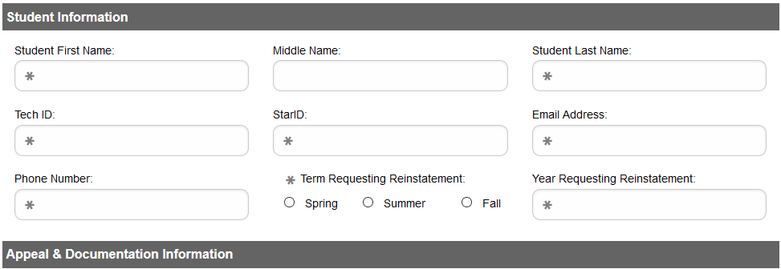
PART 1
I am appealing based on (check all that apply)  Personal physical health or mental health issue . . . . . .  Death of a family member . . . . . . . . . . . . . . . . . . . . . . . .  Military call up for active duty . . . . . . . . . . . . . . . . . . . . .  Family/relationship crisis . . . . . . . . . . . . . . . . . . . . . . . . .  Childcare . . . . . . . . . . . . . . . . . . . . . . . . . . . . . . . . . . . . . .  Medical issue not previously diagnosed or documented  Natural disaster, including flood, fire or tornado . . . . . .  Job Loss . . . . . . . . . . . . . . . . . . . . . . . . . . . . . . . . . . . . . . .  Loss of Housing . . . . . . . . . . . . . . . . . . . . . . . . . . . . . . . . .  Recent academic success at another college or university | Attach health providers’ statement written on official letterhead  Attach death certificate or obituary  Attach copy of official military orders  Attach court or legal documentation  Attach providers’ statement written on official letterhead  Attach documentation verified by Medical provider  Attach insurance documentation  Attach unemployment verification or employer termination letter  Attach insurance information or eviction documentation  Attach transcript

Disciplinary or conduct holds (in regard to a suspension or expulsion from a MinnState Institution) require attachment of the disciplinary outcome documentation to be attached.

PART 2: On a SEPARATE SHEET OF PAPER, please TYPE and attach your responses to each of the following questions.
- What were the reasons (extenuating circumstances) that led to your suspension(s)? Explain each term your GPA was below 2.0 and/or you completed less than 67% of your credits due to withdrawals or failing grade. If suspension was for disciplinary reasons, provide a detailed explanation of the circumstances that led to a disciplinary suspension or expulsion from your prior institution(s).
- What have you done to prevent these circumstances from occurring again? What will you do differently to ensure your success? What support systems do you now have in place? What services will you access to assist you?
- Briefly describe your academic and/or career goals.
If my appeal is approved, I plan to enroll in the following courses—maximum 8 credits or 2 courses (include courses you plan to repeat and student success courses you plan to take).
Course Name and Number (i.e. FYST 1100 Strategies for College Success) | Credits | Total Credits

If my appeal is approved I am required to meet the following during my first term of enrollment:
• Cumulative GPA of 2.5 or higher • No withdrawals – 100% completion rate • Enroll only in courses required by academic program

By signing below I certify my understanding that (1) I have attached all required transcripts and supporting documentation and (2) if my appeal is approved, I will agree to adhere to all conditions listed in the notification of outcome and (3) if I register and choose not to attend classes at Minneapolis College, I understand I am responsible for dropping my classes by the drop deadline and will be responsible for any charges.

Student Signature Date

Submit this form and documentation to the Admissions Welcome Center, T building room 2500, 1501 Hennepin Avenue.
The result of your appeal will be emailed to the email address listed on the front of this form within 7 business days

Appeal Results – College use only

Assessment of Appeal and Academic Records | Yes | No
Are there any financial holds?
Are there current placement tests on record or equivalent(s) shown on transcript(s)?
Transcripts and academic records are attached
Appeal includes response to the 3 essay questions has clearly addressed/identified circumstances & support
Appeal includes supporting documentation
Appeal includes a well-thought out academic plan that resolves extenuating circumstances and
aligns with academic goals (the College may amend the academic plan as needed)
Past academic record shows the ability to be academically successful
This is the student’s first suspension OR the student has met conditions of previous appeal
Other (i.e. statement of support by College official or other evidence of academic success, suspension occurred three
or more years ago, etc.)

Appeal Decision:
□ Approved for ______________________ Term, Year. All conditions within the Academic Plan section as specified by you and affirmed or amended by the College apply to your probationary term.
□ Denied based on deficiencies noted in the assessment of your appeal. If you have new information or disagree with the outcome of your appeal, you may submit a new appeal for a future term.

Signature of Minneapolis College official Date

Minneapolis College is an equal opportunity educator and employer. This document is available in alternative formats to individuals with disabilities by calling Accessibility Resource Center at 612-659-6730 or by emailing accessibility@minneapolis.edu. 8.7.2019

